Media Credenza Instructions and Troubleshooting

Logging into the Credenza:
- To begin, locate the wireless keyboard and mouse in the room. It may be under the top lid of the credenza, plugged in to charge.
- Ensure the power is on on the devices and then tap the keyboard or shake the mouse to wake up the Mac in the room.
- The TV will turn on and a standard Mac login screen will appear.
- Type your netID into the username field and use your netID password to log in

Using the attached StreamDeck to control the system:
- Once logged into the credenza Mac you will see the StreamDeck (physical keypad on top of credenza) display a number of options to you to control the room devices.
- Press any corresponding button on the keypad to execute the command (refer to image and key below)

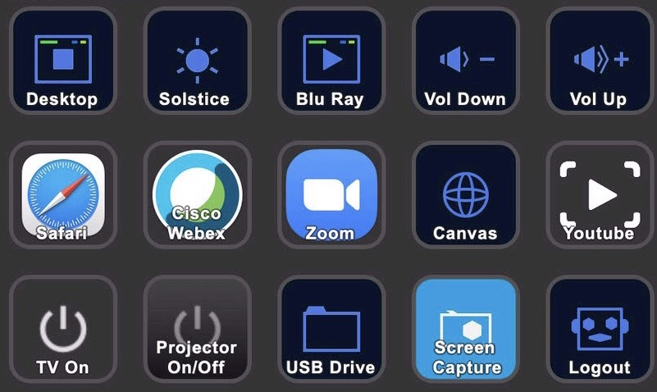

Desktop: Changes input of TV to Mac Mini | Solstice: Changes input of TV to Mersive Solstice | Blu Ray: Changes input of TV to Blu-Ray Player | Vol Down: Lowers volume of soundbar in the room | Vol Up: Raises volume of soundbar in the room
Safari: Quick launches Safari web browser | Cisco Webex: Quick launches Cisco Webex Meetings | Zoom:  Quick launches Zoom | Canvas:  Quick launches Canvas webpage | Youtube:  Quick launches YouTube webpage
TV On:  Turns on TV directly (won’t be used often) | Projector On/Off:  Turns the projector in the room on or off. (Power on takes a few seconds to warm up) | USB Drive: Launches a Finder window displaying an attached USB flash drive in USB hub | Screen Capture: Record screen or take quick screenshot of the Mac Mini | Logout:  Logs out of Mac Mini

Using the Mersive Solstice device:
- Once you have changed the input of the television to the Mersive Solstice input you will be able to wirelessly connect to the device to display your laptop or mobile device screen.
  - Note: You can also plug in the provided HDMI cable to your laptop to bypass the need to connect remotely to the Solstice. You must still switch the input to the Solstice using the StreamDeck
- Download the Mersive Solstice application by navigating to the IP address of the Mersive unit in your web browser:
  - IP Addresses:
    - 524A: 172.19.52.176
    - 524B: 172.19.52.186
- Once the application is downloaded and launched use the Screen Key on the screen to connect.
- More information on the Mersive Solstice can be found at https://documentation.mersive.com/content/pdf/solsticeinroomprintout.pdf

General Troubleshooting Techniques:

If you encounter an issue while using the Media Credenza please try the following steps to resolve the issue.

- If the TV does not turn on while shaking the mouse or tapping keyboard:
  - See if there is anything displayed on the StreamDeck buttons:
    - If yes: Turn on TV manually by pressing small black button in bottom-middle of the screen
    - If no: Open flip top lid of credenza and manually power on Mac by pressing power button on the back of the machine
- If the attached video conferencing camera does not activate:
  - Restart Mac Mini computer by navigating to the Apple logo on the top left of the screen and selecting Restart from the drop down box
- If the wireless mouse or keyboard are not functioning:
  - Ensure the device is powered on by locating the power slider on the device and sliding it to display a green background
  - Plug the affected device into the credenza using the provided white power cables
  - Unplug it after a minute and try again
  - DO NOT FORGET TO LOGOUT

